|  |  |
| --- | --- |
| **Name:** | Rishav Dugar |
| **Roll Number:** | 19IM3FP30 |

1. **Aim of the experiment**  Familiarisation with Signal Generator, Oscilloscope and Studies on RC, CR and RL circuits
2. **Tools used:** Resistors, Capacitors, Inductors, Multimeter, Oscilloscope, Sinusoidal Voltage Source, Square wave Voltage Source
3. **FOR STUDY ON RC AND CR CIRCUITS( VLABS, LTSPICE )**
4. **Background knowledge (brief):**

Filters are frequency selective electronic components. It is based upon the frequency dependence of impedances. In high pass filters(HPF) the output is across resistor as Xc is low for higher frequencies and in low pass filters(LPF) the output is across capacitor as Xc is high for lower frequencies.The cutoff frequency is that frequency at which the power falls to half.

Xc = 1 / ( 2pfC) XL = 2pfL

Vo = Z2 / ( Z1 + Z2 ) * Vi i.e. Vo is proportional to impedance across output

fc = 1 / ( 2pRC) or fc = R/ ( 2pL)

1. **Circuit (hand drawn/image)**

HPF LPF

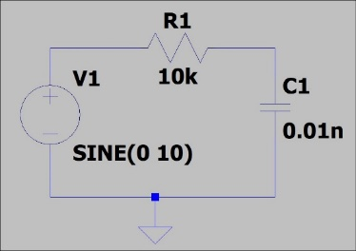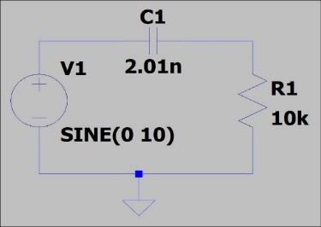

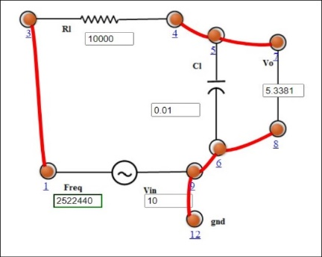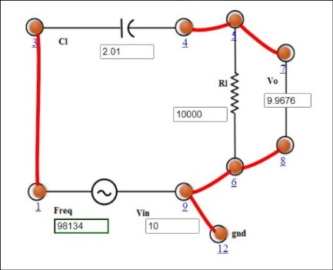

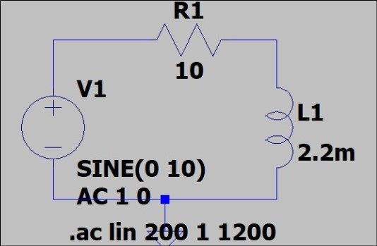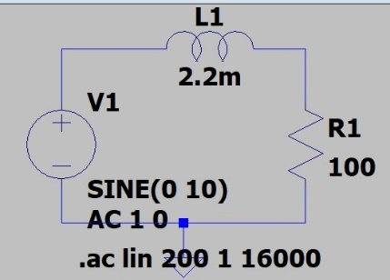

1. **Measurement Data (Tabular form)**

RC HPF

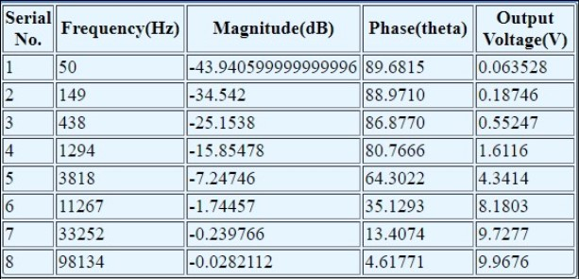

RC LPF

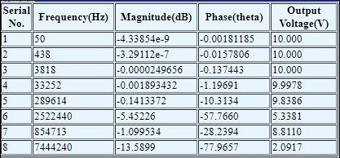

1. **Graph (Image)/Screenshots**

RC HPF

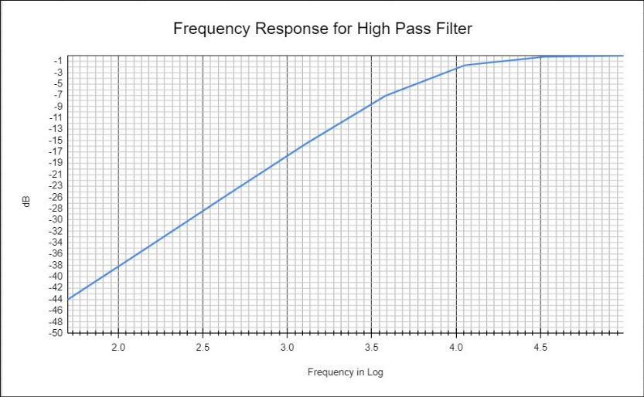

RC LPF

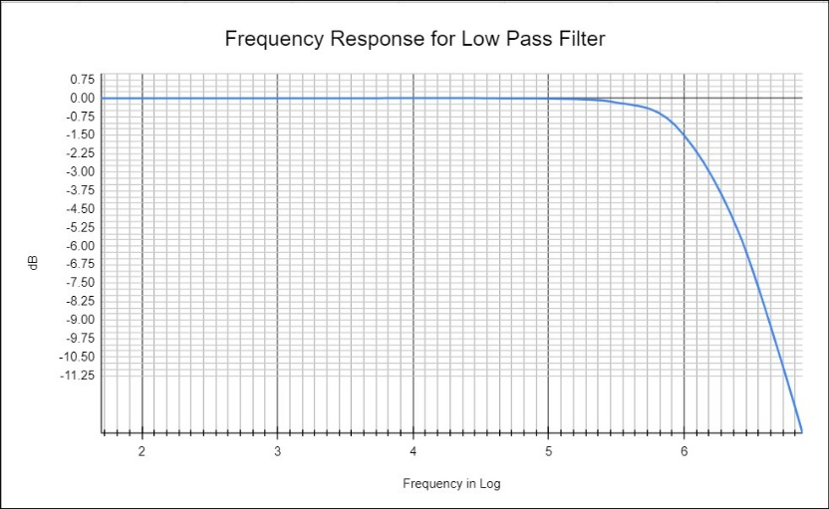

RL HPF

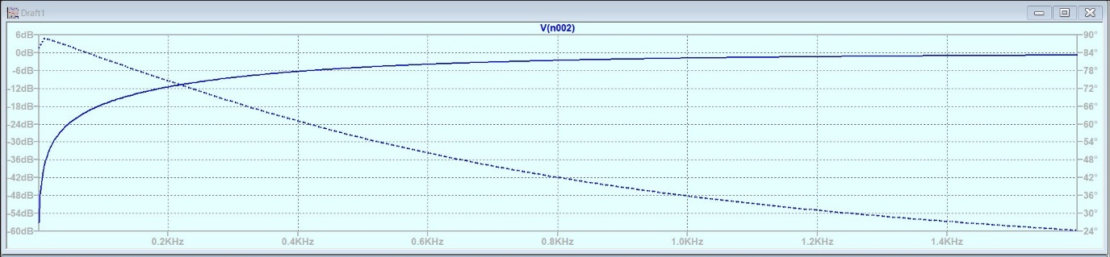

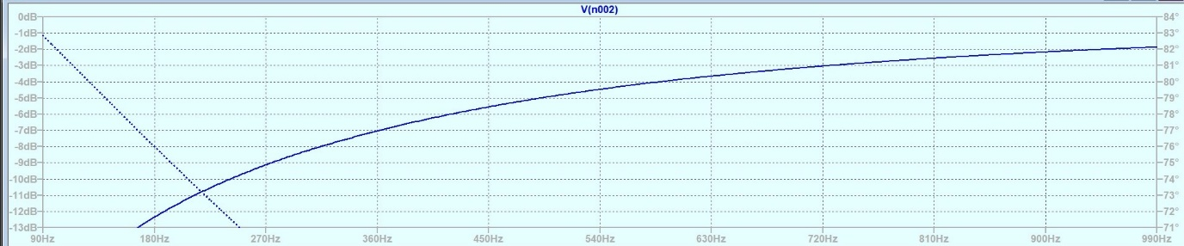

RL LPF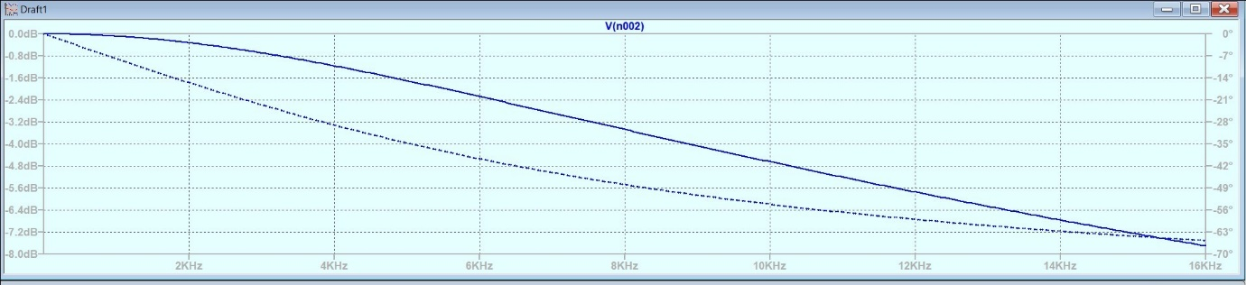

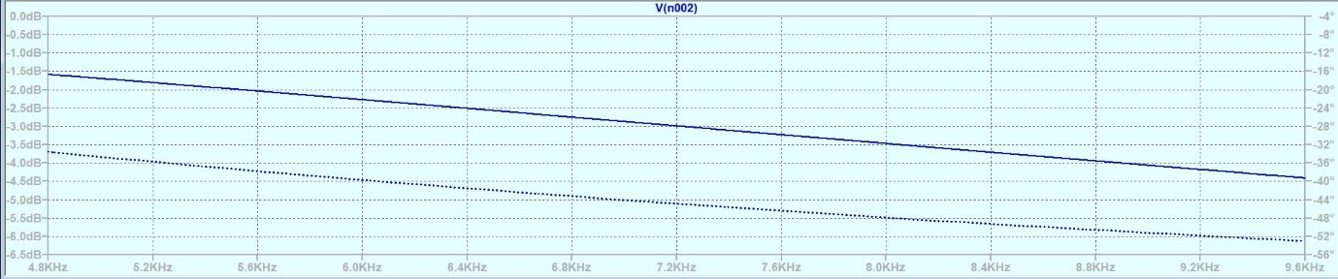

1. **Conclusion**

RC HPF

From graph the cutoff frequency comes out to be ~8111Hz

While calculated frequency is ~7922Hz

Error = 2.4%

RC LPF

From graph the cutoff frequency comes out to be ~1520KHz

While calculated frequency is ~1592KHz

Error = 4.5%

RL HPF

From graph the cutoff frequency comes out to be ~720Hz

While calculated frequency is ~724Hz

Error = 0.55%

RL LPF

From graph the cutoff frequency comes out to be ~7.2KHz

While calculated frequency is ~7.24KHz

Error = 0.55%

Error is within experimental limits.

**B) FOR STUDY ON OSCILLOSCOPE( FALSTAD )**

1. **Background knowledge (brief):**

The oscilloscope is an instrument to observe the waveform. When square waveform is applied across filters different waveforms are achieved. This is dependent upon the time period(T) of input waveform as,

T > 5t or T<5t

A RC LPF acts as an integrator. It integrates the input signal into triangular waveforms(ideal). But we achieve saw teeth shaped waveforms in real experiments. Vo increases as capacitor charges.

T>5RC(charges fully) T<5RC(partial charged)

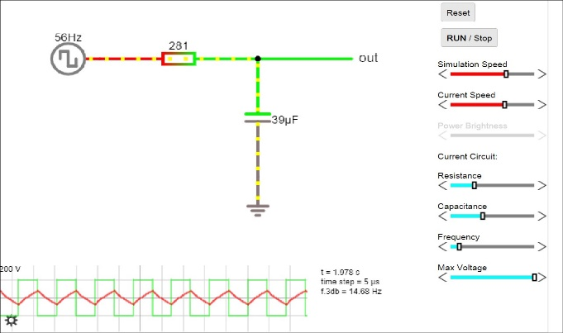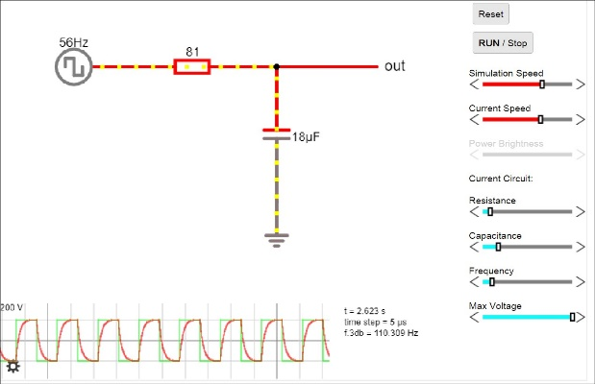

A RC

A RC HPF acts as an differentiator. It differentiates the input signal into frequency spikes. Vo decreases as capacitor charges.

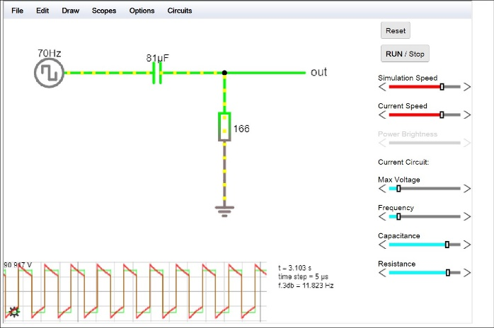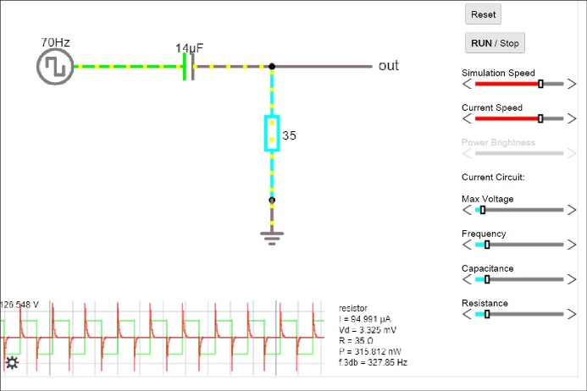T>5RC(charges fully) T<5RC(partial charged)

A RL HPF acts as an differentiator also. It differentiates the input signal into frequency spikes. Vo decreases as steady stage is reached.

T>5R/L T<5R/L

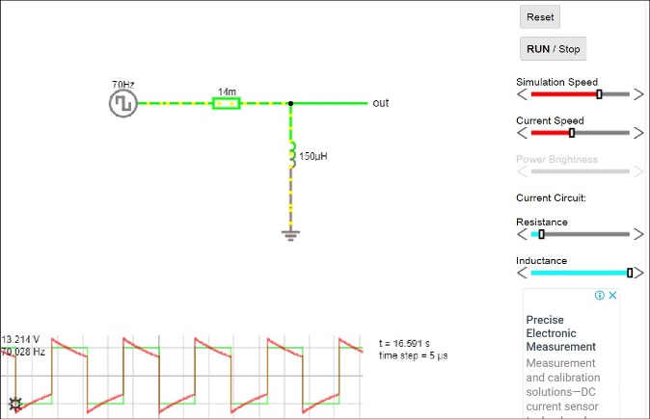

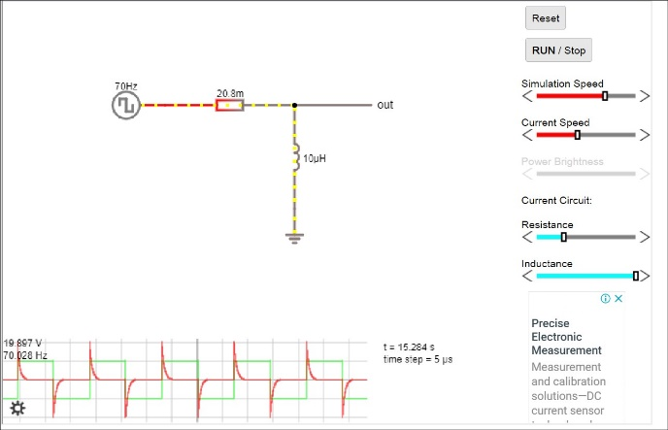

**Discussion:**

In this experiment we have learnt about the frequency selective nature of RLC circuits. The cut-off frequency is the point where power transmitted falls to half. We have also seen the integrating and differentiating effects of RLC filters on waveforms particularly square waveform in our case. All these are carefully based on the response of capacitors and inductors to AC signal ( time constant ). This enables us to choose selective frequency range and convert the input into a desired output waveform.